BYOxLink – How to Guide

Install the My Apps portal for iOS devices
This document explains how to install and use the My Apps portal on iOS devices.
The My Apps portal:
- provides one-stop place to launch school web-based applications and to access learning websites
- allows single sign on to some school cloud applications.
These instructions are for personal and school owned devices, assigned to individual users, and using version 12.2+ of iOS.
Please contact your school IT if you experience any problems with this process.

Step 1. Launch the company portal
- Select the Comp Portal app icon.
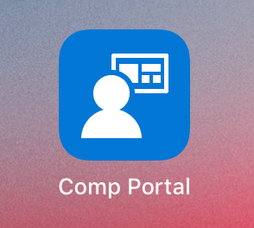

- Select Sign In to sign in to the company portal.
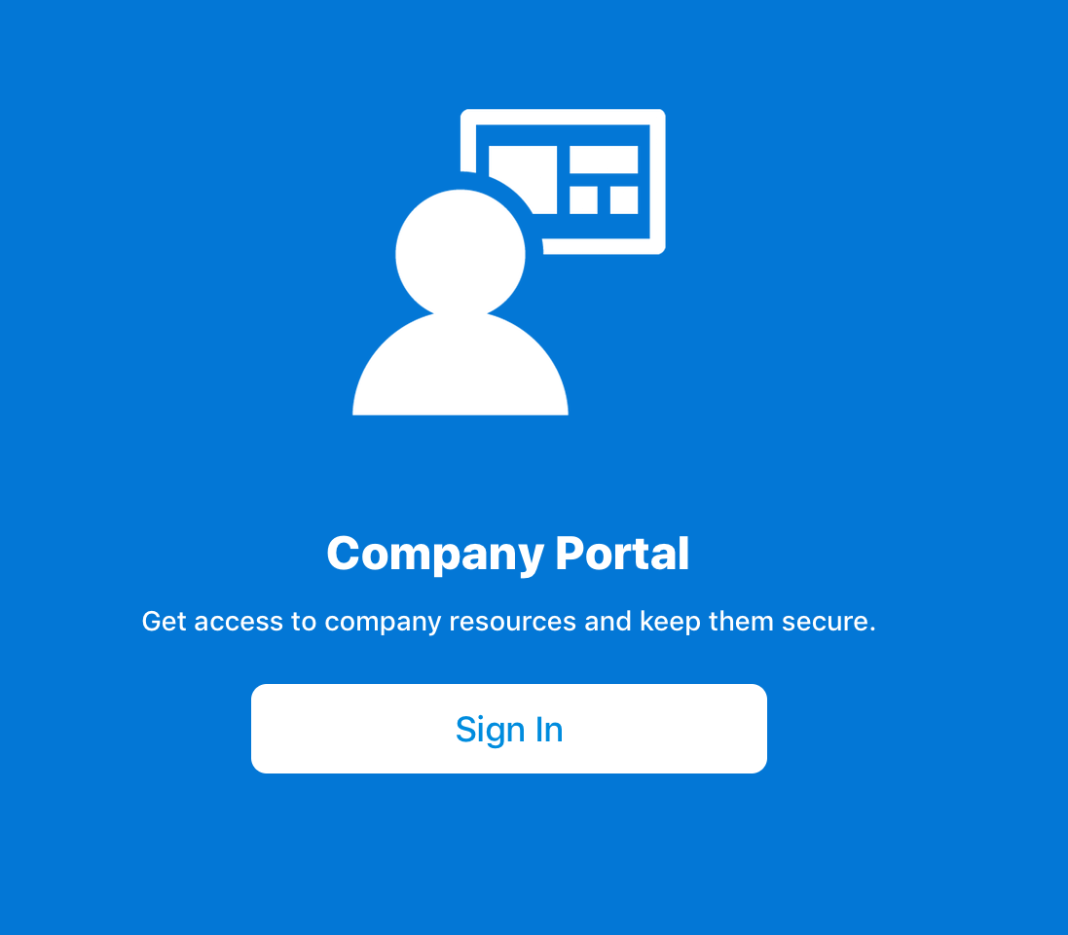
- Type your school email address and select Next.
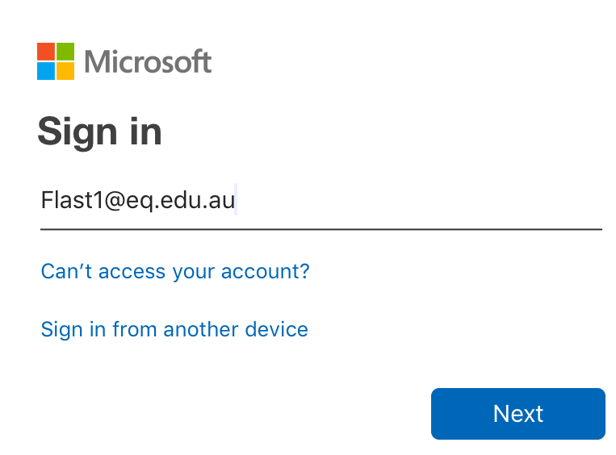

- Enter your school username and password. Accept the terms and conditions. Select Sign in.
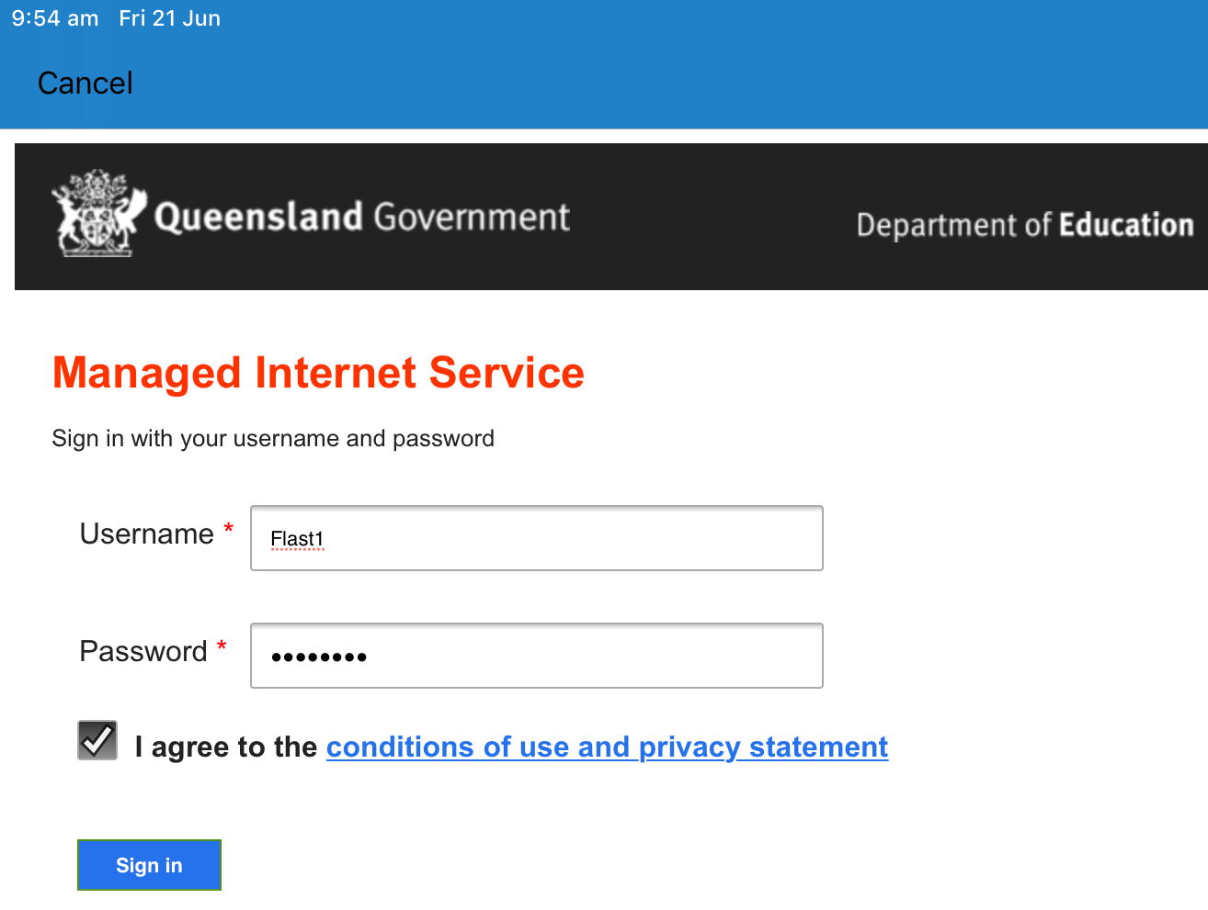

Step 2. Install My Apps portal
- The company portal will open.
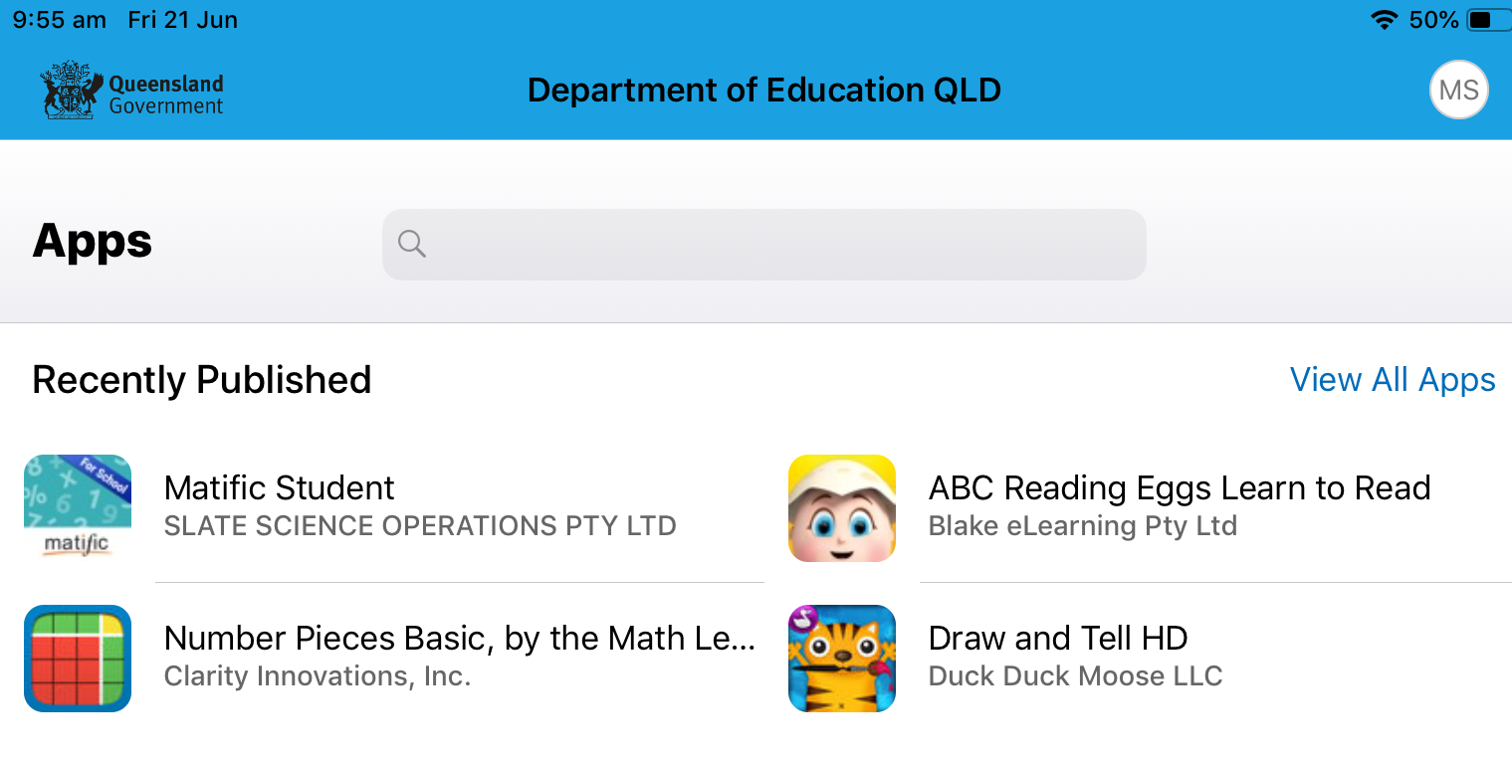

- Type My Apps into the search bar and select the My Apps – Azure Active Directory when it appears.
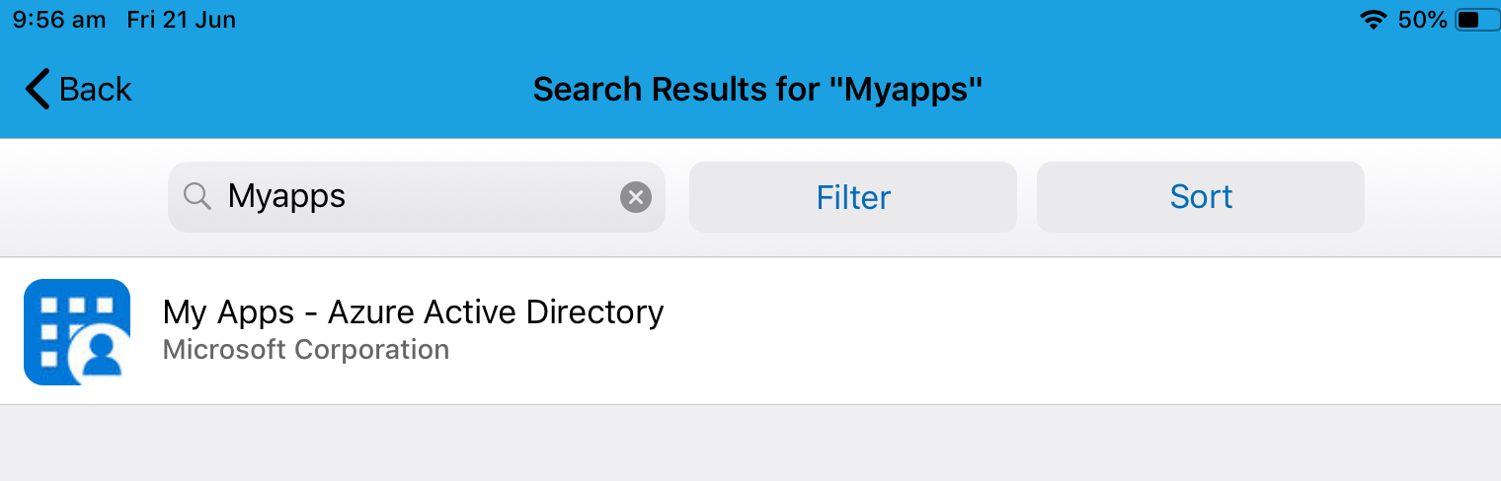

- Select Install.
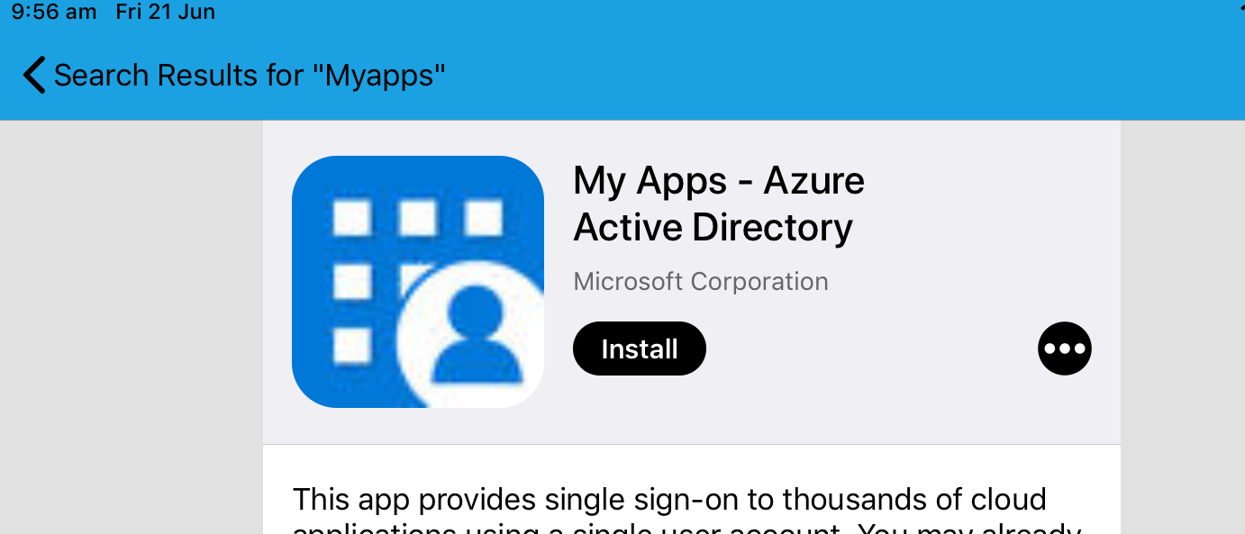

- Select Install again to confirm the installation.
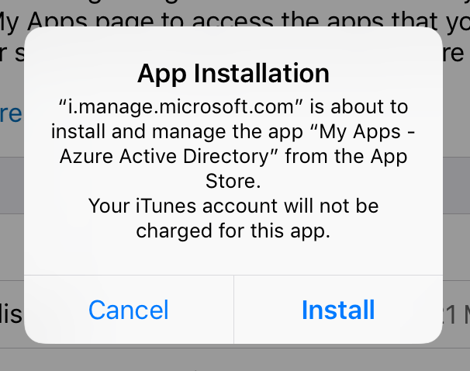

- Wait while the app installs. The status will show as Pending install.
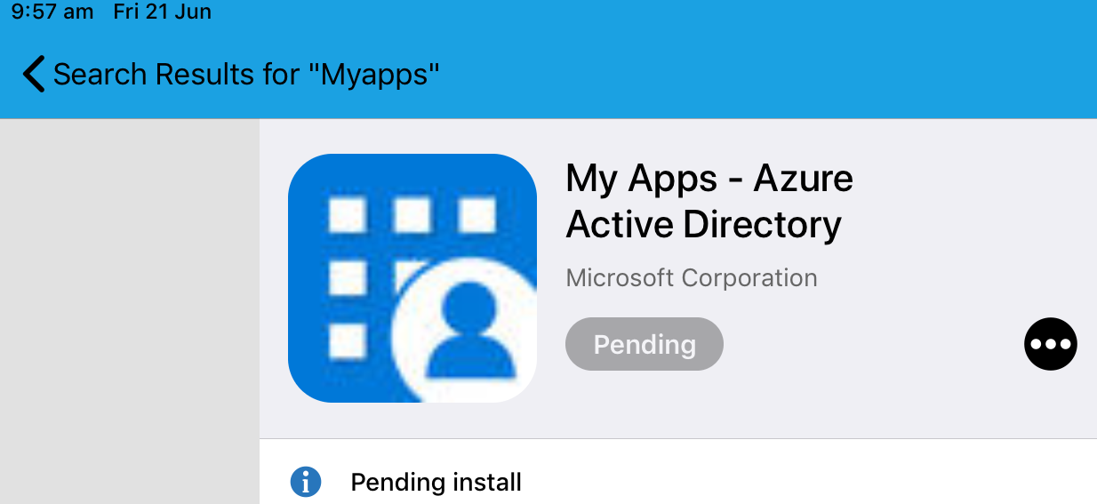

- The status may move to Installed but this does not always happen.
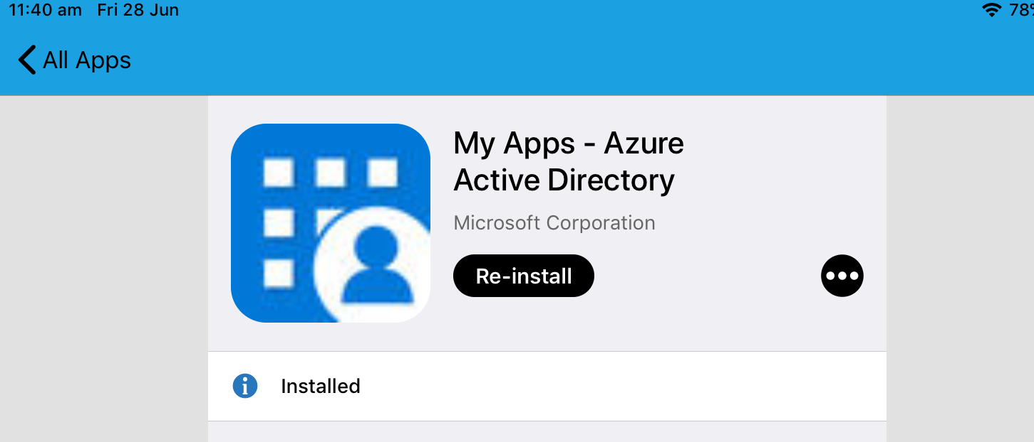

- Minimise the company portal from time to time to check if My Apps app is installed and available. Once available, select the My Apps icon.
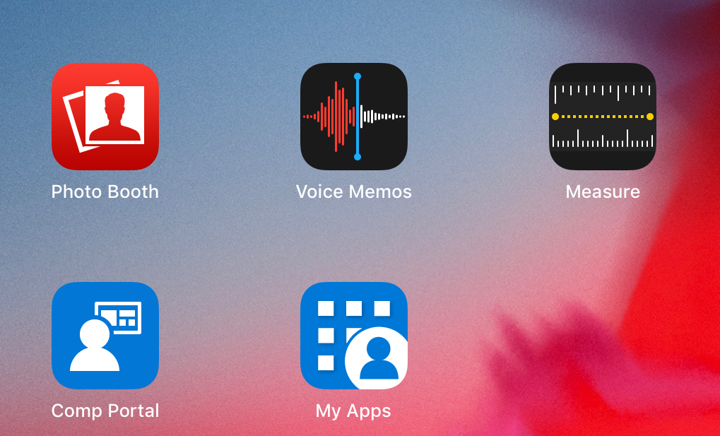

- The My Apps portal will display. You may now select and use the school web-based apps available to you.
