BYOxLink – How to guide

Install the My Apps portal on Windows devices
This document explains how to install and use the My Apps portal on Windows devices.
The My Apps portal:
- provides a one-stop place to launch school web-based applications and to access learning websites
- allows single sign-on to some school cloud applications.
These instructions are suitable for devices using Windows 10 version 1607+.
Please contact your school IT if you experience any problems with this process.

Step 1. Launch the company portal app
- Select the Windows icon 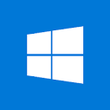 at the bottom left hand of the screen and then select the Company Portal app.
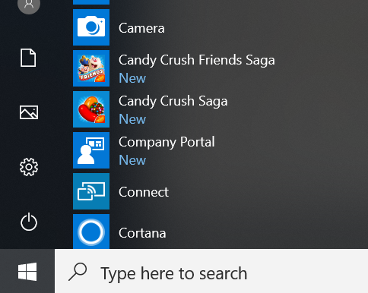

- If prompted with a Sign in screen, enter your school email address and select Next.
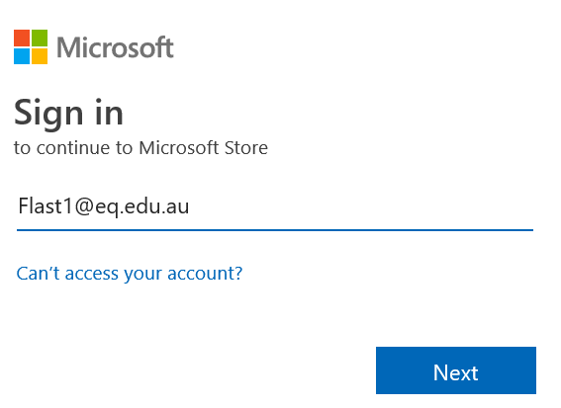

- Next, you may be asked to sign in. Enter your school username and password. Accept the terms and conditions and select Sign in.
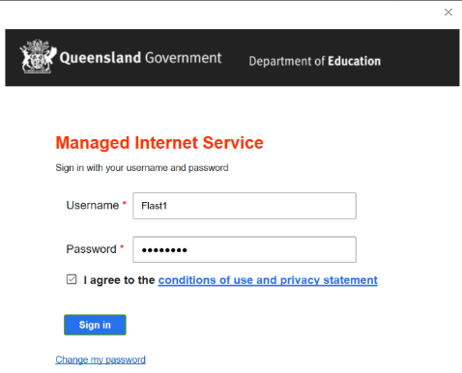

- The company portal will open and display.
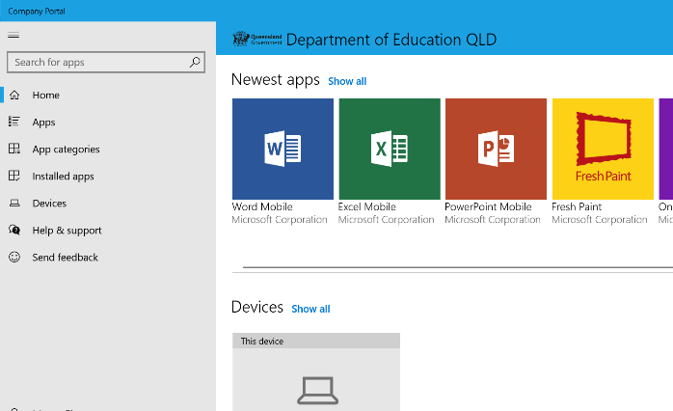

Step 2. Install My Apps Secure Sign-in Extension
- Type My App in the search bar and then select My Apps Secure Sign-in Extension.
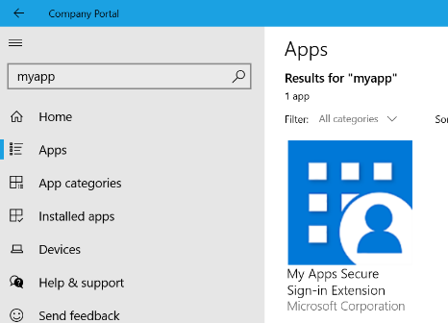

- On the next screen display, select Install.
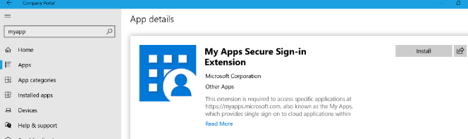

- Wait while the My Apps Secure Sign-in Extension app downloads. To begin, the screen shows Download pending. The screen will then show Installed once installation is complete.
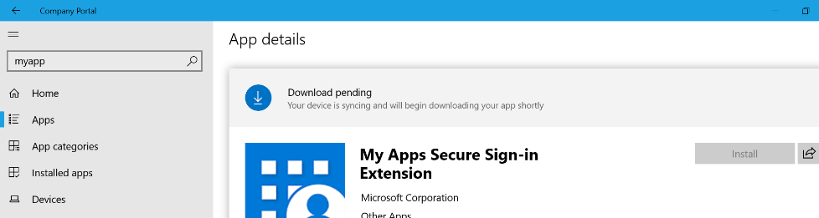

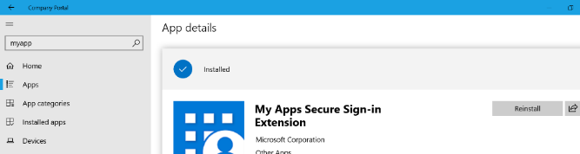

Step 3. Open My Apps Secure Sign-in Extension
- Once the My Apps Secure Sign-in extension is installed, you can open the Microsoft Edge internet browser .
Note: This guide describes using the My Apps extension in the Microsoft Edge browser. However, the My Apps extension can also be downloaded for other browsers through their extension portals.

- A pop-up screen will display. Read the actions that the My Apps Secure Sign-in Extension can do. Select Turn it on to accept these conditions.
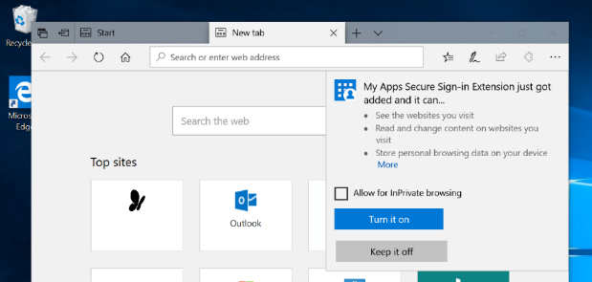

- Select the My Apps icon in the top right hand of the screen and then select Sign in to get started.
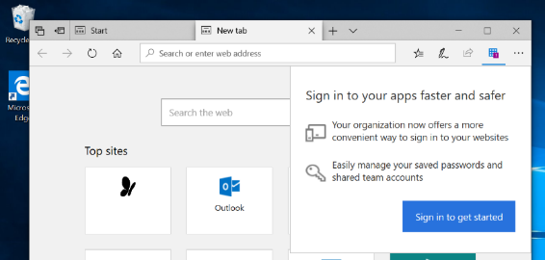

- You may be asked to sign in to My Apps portal. If so, please sign in using your school credentials.

- You may be asked if you would like to stay signed in, select the option to stay logged in.

- Select the My Apps icon in the upper right hand of the screen and then select My apps.
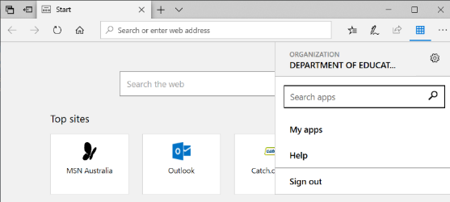

- You can now use the school websites and web-based applications made available to you.
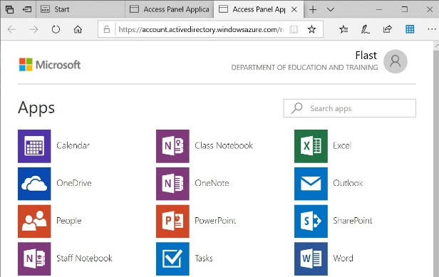

Note: There is a recently used apps feature. Select the My apps icon to see the apps you have recently used.
