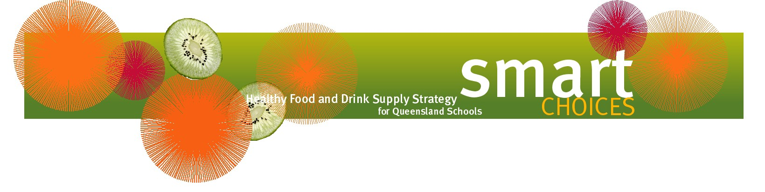

Smart Choices - Healthy Food and Drink Supply Strategy for Queensland Schools

Smart Choices is all about supplying healthy food and drink choices to students in Queensland schools.
School food and drink supply includes all situations where food and drink is supplied in the school environment – tuckshops, vending machines, school excursions, school camps, fundraising, classroom rewards, school events such as celebrations and sports days, and food used in curriculum activities.

Reflecting the Australian Dietary Guidelines and The Australian Guide to Healthy Eating, Smart Choices categorises foods and drinks into three groups:

GREEN – Have Plenty
Encourage and promote these foods and drinks in the school.

GREEN foods and drinks are drawn from the basic five food groups and are low in saturated fat, sugar and/or salt and rich in nutrients. These foods should feature prominently in the school environment.

Foods and drinks that fit into the GREEN category include fruit, vegetables, wholegrain or high fibre bread and cereals, reduced fat milk, cheese and yoghurt, lean meat, fish and poultry, eggs, nuts, water and reduced-fat milks.

AMBER – Select Carefully
Do not let these foods and drinks dominate choices and avoid large serve sizes.

AMBER foods and drinks are mainly processed and have had some sugar, salt or fat added to them. These products should not dominate at the expense of healthier choices. A selection that consists mostly of AMBER foods and drinks will provide students with choices containing too many kilojoules at the expense of fresh choices.

RED - Occasional
Limit the availability of these foods and drinks to no more than two occasions per term.

The ‘occasional’ foods and drinks that make up the RED category are based on the ‘extra’ foods as defined in The Australian Guide to Healthy Eating. These foods and drinks should only be consumed occasionally because they lack adequate nutritional value, are high in saturated fat, and/or added sugar and/or salt, can contribute excess energy and can contribute to tooth decay and erosion.

