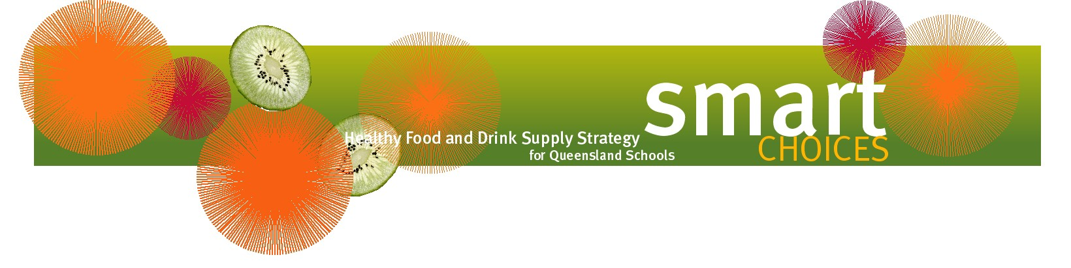

Milk and flavoured milk drinks

Smart Choices is all about supplying healthy food and drink choices to students in Queensland schools and is based on the Australian Dietary Guidelines and The Australian Guide to Healthy Eating. Both of these documents emphasise the importance of milk as part of a healthy diet.
Why is milk important?
Milk (and yoghurt, cheese and/or alternatives like soy products) is an important source of calcium and protein for growing children and adolescents. Milk also provides other essential nutrients such as vitamins A and D, some B group vitamins, potassium, phosphorus and carbohydrate.
It is recommended that children and adolescents consume 1½ to 3½ serves of milk, yoghurt, cheese and/or alternatives every day. A serve of milk is 250mL, or one cup. For children aged over two years, reduced fat varieties are recommended because they are lower in unhealthy saturated fats and lower in energy (kilojoules).
What about flavoured milk?
The best drinks for children are water and plain milk. However, flavoured milk can also be included as part of a healthy eating pattern. This is particularly the case as children move into adolescence, a time when they need the most calcium but tend to drink less milk and more sugary drinks.

Although flavoured milk contains added sugar, it also contains calcium, protein and the other nutrients listed above. These are generally not present in other common foods with added sugar, such as soft drinks. Reduced fat flavoured milks are a better choice than full fat flavoured milks.
How are milk and flavoured milk classified in Smart Choices?
Plain reduced fat milk is classified as GREEN. Plain full fat milk and all flavoured milk products are classified as AMBER. The maximum serve size for flavoured milk drinks is 500mL.

Coffee milk drinks can only be sold to secondary students (cannot be supplied to primary school students) and the maximum serving size is 375ml.
These milk products do not need to be assessed against the Smart Choices ‘Occasional’ (RED) food and drink criteria tables.
Tips to increase milk sales in the tuckshop
- Display milk drinks prominently by positioning them in the centre spaces of the fridge.
- Include a milk drink as part of a ‘meal deal’.
- Freeze flavoured milk in ice-block containers to make ‘frozen milk ices’.

