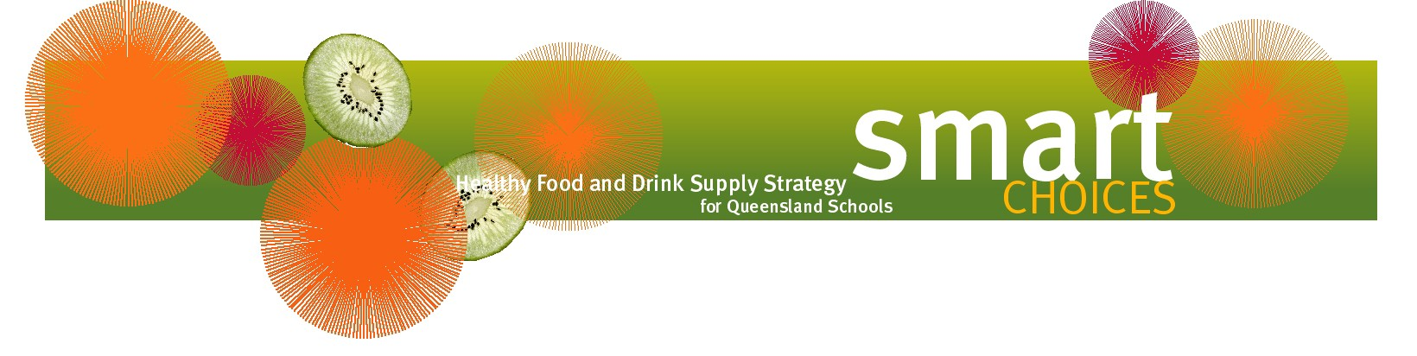

Quick and easy healthy snack ideas

Cold snacks
- fresh fruit (diced)
- frozen fruit pieces
- vegetable pieces (carrot, celery, zucchini) in slices/sticks
- vegetable sticks with hummus dip
- fruit or vegetable kebabs
- dried fruit and nut packs (raisins, currants, sunflower seeds, pumpkin seeds, suitable nuts)
- reduced fat cheese sticks/cubes/slices
- small reduced fat plain or fruit yoghurt/frozen yoghurt
- slice of raisin/fruit bread or toast
- rice cakes/corn cakes/crispbread with hummus or vegemite
- fingers/triangles of bread spread with grated vegetables mixed with plain yoghurt
- reduced fat custard
- rice cakes topped with reduced fat cheese

Hot snacks
- mini fruit/vegetable muffins
- ½ jaffle
- corn cob
- boiled egg
- air popped popcorn (with no added salt/butter)
- scones (plain/fruit/cheese/pumpkin)
- toasted English-style muffins with tomato and cheese
- ½ boiled potato topped with grated reduced fat cheese
- pikelets

Drinks
- plain water
- reduced fat plain milk

Further information on Smart Choices can be found on the Department of Education’s website
https://education.qld.gov.au/students/student-health-safety-wellbeing/student-health/smart-choices/.

