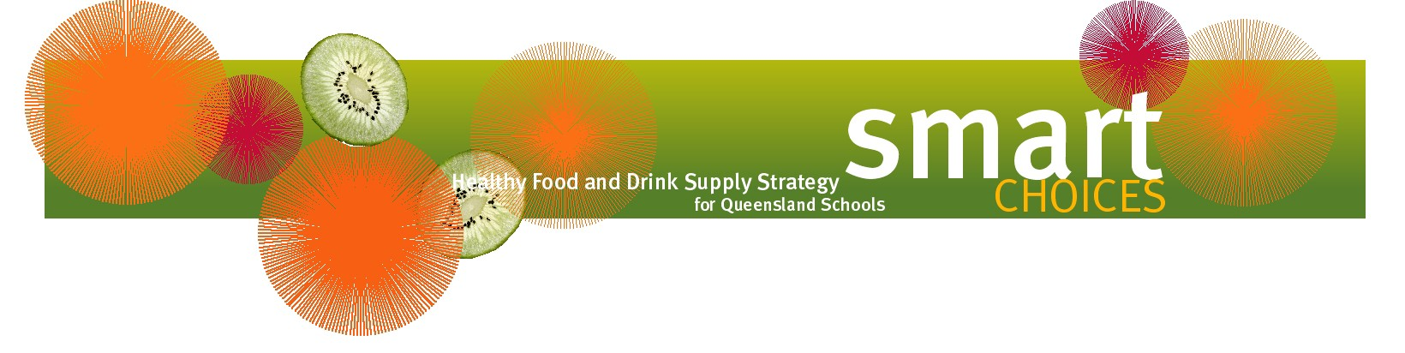

Healthier school discos

School discos are often used to raise funds through the sale of RED items like soft drinks and lollies. With some extra creativity, these events can be consistent with Smart Choices while still raising funds for schools.

Consider the following ideas:
- sell water, juice or flavoured milk instead of soft drinks
- purchase or hire a fruit slushie machine
- set up a smoothie bar where children and young people can create their own healthy drinks
- purchase or hire a popcorn machine and serve the popcorn in movie-style cardboard boxes (avoid butter and salt – try olive oil instead if required)
- if there is access to a kitchen, serve snacks that are consistent with Smart Choices. Examples include toasted pita bread or rice crackers with salsa, reduced-fat cheese and guacamole, and homemade pizzas with lean meat, lots of vegetables and a sprinkle of reduced-fat cheese
- ask parents to donate items from a selection of healthy recipes, like those available from QAST (https://qast.org.au/emenu/) or Nutrition Australia Queensland (https://naqld.org/recipe/). Talk to the tuckshop convenor about any food safety requirements.

Non-food ideas may include:
- adding some colour to the event by selling glow sticks, coloured hairspray or face painting
- having a dress-up theme with small prizes for the best dressed
- having a lucky door prize such as a voucher from the tuckshop or voucher to purchase music online, with each child or young person receiving a ticket when they enter the disco.

